Epping Recreation & Edelweiss Farm Horsemanship Program
Does your child love and want to learn more about horses?
This 4-week program is a great opportunity for them!
Each week will include mounted horse time and learning hands on barn skills.
No previous experience needed. Grades 2+ Welcome!
When:
Thursdays May 17th, 24th, 31st and June 7th
From 3:30-5:00pm
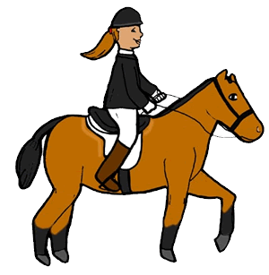
Transportation Provided by Epping Rec from School to Barn If Needed
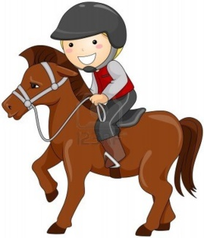
Where:
Edelweiss Farm
3 Towle Rd Epping, NH
What to Bring:
Riding Helmet
Boots with a Heel
Jeans

If Interested Please Fill Out the Registration Form Below and Pay the $180 Fee to Hold your Spot
Min 5 Participants Max 12
Please Email eppingrecreation@gmail.com with any questions!

Participant Name: ________________________________________ Age: ______ Grade/Teacher: _________________

Parent/ Guardian Name:__________________________________ Phone:_____________________________________

Address: ____________________________________Town: ___________ Work Phone: _________________________

Email Address(for program information / updates):_________________________________________________________
Please “like” us on Facebook for last minute program updates! (Epping Parks & Recreation Department)

Important medical history we should know about: ________________________________________________________
Transportation To Program by Epping Rec. Bus Needed: ___ YES ___ NO

Permission to Participate and Parental Acknowledgement:
I understand injuries to participants can occur during recreational activities. I understand that this minor child will be dropped off at designated locations and will need to travel home on his or her on volition without the supervision of the Town of Epping Recreation Department, its representatives, or employees. As parent/guardian, we understand that appropriate arrangements must be made to pick up the child. I understand that activities and transportation have inherent foreseeable and unforeseeable risks and dangers associated with them. Risks and dangers may include, but are not limited to: motor vehicle travel, exposure to forces of nature, time of day, remoteness from medical facilities, insufficient cellular phone coverage, encounters with persons not associated with the Town of Epping Recreation Department or the minor child, physical and mental challenges. I acknowledge that this child’s participation at the Epping Recreation Department is voluntary.
I have read this form and fully understand that by signing this form I acknowledge and accept such risks.
By signing below, I acknowledge that I have read and understand the above statements.

Parent/Guardian/Participant Signature: _____________________________________________ Date: _______________________
(Not A School Sponsored Event)

