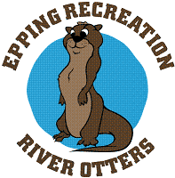 Family Music Classes: 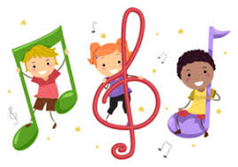

Come join us for Family Music Class at Watson on Wednesdays with Mrs. Avery! Each class will be filled with singing, movement, and instrument play; all designed to stimulate musical learning. This is the perfect way to sing and play with your little one(s) and connect with them through music!
Family Music Class
Day: Wednesdays, Session 2: May 4, 11, 18, 25 June 1, 8
Time: 9:30am-10:15am
Cost: Age 9 months-5 years $60/6 week session; $12/class drop in rate (if space allows); Siblings under 9 mo. are free
Location: Watson Academy (Epping Recreation Center located at 17 Academy St., just before HS Entrance)

To Register, please complete the form below and return with payment to Recreation Dept.
(Checks made payable to “Town of Epping”)

Participant Name: ____________________________________ Home Phone:____________________

Address: __________________________________Town: _________ Cell Phone: __________________

Email Address(for program information / updates):____________________________________________

Important information we should know about: ____________________________________________
_____________________________________________________________________________________
(Masks optional for this program!)
Please “like” us on Facebook for last minute program updates! (Epping Parks & Recreation Department)

Drop off Reg. Form to Town Hall or Watson Academy in Epping or mail to:

Epping Parks & Recreation Dept.
157 Main Street
Epping, NH 03042

