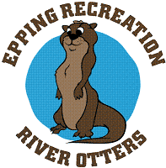 Youth Ceramics Classes: 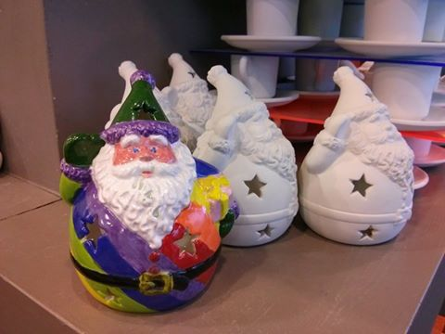

Come join us for Ceramics Class at Watson on Thursdays!
We offer classes for Youth and for Adults.
Youth Ceramics Class
Day: Thursdays, Session 1: Nov. 9, 16,30
Time: 4:30-5:30pm
Cost: $20 For three sessions
Includes: 1 piece per class
Location: Watson Academy (Upstairs Blue classroom)

To Register, please complete the form below and return with payment to Recreation Dept.

Participant Name: ____________________________________ Home Phone:____________________

Address: __________________________________Town: _________ Cell Phone: __________________

Email Address(for program information / updates):____________________________________________

Important medical history we should know about: ____________________________________________
_____________________________________________________________________________________
Please “like” us on Facebook for last minute program updates! (Epping Parks & Recreation Department)

Drop off Reg. Form to Town Hall or Watson Academy in Epping or mail to:

Epping Parks & Recreation Dept.
157 Main Street
Epping, NH 03042

